SECTION KC

SEA WATER PUMP AND DRIVE

CONTENTS

Chapter

Description .. .. .. .. .. .. .. .. .. 1

PUMP DRIVE

Drive Belt Replacement .. .. .. .. .. .. .. 2

Maintenance .. .. .. .. .. .. .. .. .. 3

SEA WATER PUMP

Removal and Dismantling .. .. .. .. .. .. .. 4

Cleaning and Inspection .. .. .. .. .. .. .. 5

Assembly and Fitting .. .. .. .. .. .. .. 6

CHAPTER 1

DESCRIPTION

Sea Water Pump Drive (Fig KC.I)

1. To enable the sea water pump to be driven by the engine, the crankshaft is extended through the engine free-end cover by means of drive shaft adaptor (6), bolted and dowelled to the crankshaft and sealed at the free-end cover by an oil seal (Section FF).
2. Drive pulley (19) is dowelled to drive shaft adaptor (6) and secured by setscrews (61) and locking plates (62). The drive is transmitted from drive pulley (19) via drive belts (48) to pump pulley (46), which is keyed to pump drive shaft (50) and secured by philidas nut (51).
3. The drive belts are tensioned by jockey pulley (40). The pulley runs on bearings (38) carried on spindle (37), which is mounted to adjuster plate (28) thin nuts (34) and plain washers (35). A bracket forming part of support (20) accommodates adjusting screw (29) and is positioned in the bracket by collar (24) pinned to the adjusting screw.
4. Belt tension is adjusted by rotating adjusting screw (29) to move adjuster plate (28) along slots in support (20).

Sea Water Pump (Fig KC.2)

1. The sea water pump is a lightweight self priming, single stage centrifugal type operating on the diffuser priming principle, and consists of a tank, valve housing, bearing housing and impeller/shaft assembly. Rotation is clockwise looking on the pump drive shaft end.
2. Shaft (14) is carried by bearings (15) and (17) in bearing housing (16). Bearing (15) is of the sealed for life type, with shields on both sides of the bearing, whilst bearing (17) has one shield on the bearing chamber side and is pre-packed with grease during assembly. No provision is made for external lubrication during the life of the bearings. Grease seal (18), grease seal cap (12) and flinger plate (11) prevent water entering the bearing housing. Seal plate (5) and bearing housing (16) are secured to tank (3) by studs, nuts and spring washers.
3. Seal plate (5) carries the stationary element of rotary seal assembly (10). This consists of ceramic counterface (45) and rubber carrier (46) pressed into a recess in seal plate (5). The rotating element of the seal assembly is carried on shaft (14) and consists of carbon seal (44) held in contact with the ceramic counterface by spring (42) bearing against drive and carrier (43). The drive for the rotating element is transmitted from shaft (14) to carbon seal (44) by rubber drive and carrier (43).
4. Impeller (19), taper mounted to and keyed to shaft (14), and secured by domed nut (22) and tabwasher (21), is enclosed by diffuser (20). The diffuser is spigot mounted to tank (3) and sealed to valve housing (1) by 'O' ring (23) fitted in a recess in the diffuser.
5. Valve housing (1) secured to the tank by studs, nuts and spring washers, carries clack valve (31). The valve consists of valve seat (36) secured to the valve Tfousing by studs, nuts and spring washers, clack valve (31), upper weight (30) and lower weight (32) secured to the clack valve by a nut and bolt.
6. Suction branch (29) is secured to valve housing (1) by studs, nuts and spring washers.

DRIVE BELT REPLACEMENT

1. Should it be found necessary to replace the drive belt set only, ie. if the need for replacement arises between maintenance periods, proceed as follows:-
2. Remove setscrews (22)(Fig KC.l) and spring washers securing cover (23) to the front of jockey pulley support (20), remove cover.
3. Remove setscrews (49)and (33) and spring washers and remove guard (44)
4. Remove 2BA screws (16) and spring washers, and setscrews (15) and spring washers securing crankshaft pulley guard (18), and remove the guard.
5. Slacken adjusting screw locknut (27), slacken philidas nuts (25) securing adjustment plate (28) and using a suitable 19 mm A/F spanner on the hexagon machined at the top, rotate adjusting screw (29) clockwise to slacken the tension on drive belts (48), until they can be removed from pump pulley and crankshaft pulley and withdrawn.
6. Take the first belt (48) of the new set and pass it through the right hand aperture to pass over crankshaft pulley (19), and locate it in the pulley groove nearest the engine. With the belt passing either side of jockey pulley (40), engage belt with pump pulley (46), and locate in the groove nearest the pump. Ensure that the belt does not become twisted in the process. Repeat for the remaining belts. Rotate adjusting screw (29) anti-clockwise whilst guiding the belts into their respective jockey pulley grooves.
7. As tension is applied, deflect the belts with the finger tips until apparent movement ceases. Check that the belts are correctly tensioned by applying a load, at right angles to ONE belt to obtain a deflection of 9 mm (0.375 in). Measure this force using a spring balance. This should fall within the range 2- 2.7 kgf (4.4 - 5.9 lbf) with the higher figure for new belts, to allow for the belts stretching during running-in.
8. When the correct deflection has been obtained, tighten nuts (25) and (27) and replace and secure guards (18) and (44) and cover (23).

NOTE Drive belts should not be over-tensioned as this may affect crankshaft deflections. Refer to Section FF, and check deflections after retensioning or fitting new drive belt sets.

CHAPTER 3

MAINTENANCE

Removal (Fig. KC 1)

1. Isolate and drain the sea/raw water system.
2. Remove the pump suction and delivery piping.
3. Remove covers, guards and drive belts (see Chapter 2).
4. Attach suitable lifting gear to the pump, remove setbolts (45) and philidas nuts (47), setscrews (57) and spring washers securing sea water pump (55) to pump bracket (1), remove the sea water pump.
5. Remove setscrews (59) and spring washers securing pump bracket (1) to free-end cover (60), and remove pump bracket (1).
6. Remove grease nipple (31), and grease nipple adaptor (30) together with fibre washers (65), from jockey pulley spindle (37) and adjustment plate (28).
7. Remove setscrews (17) and spring washers from jockey pulley support (20). Remove capscrews (13) and spring washers and remove upper and lower support brackets (8).
8. Drive out taper pin (21), from collar (24). Unscrew adjusting screw (29) from jockey pulley adjustment plate (28), unscrew locknut (27) and remove adjusting screw and collar from jockey pulley support.
9. Remove thin nuts (34) and washers (35) securing spindle (37) to adjustment plate (28). Remove jockey pulley assembly from the adjustment plate.
10. Remove philidas nuts (25) and washers (32), securing adjustment plate (28), remove the plate.
11. Turn back locking plate tabs (62), remove setscrews (61), together with locking plates (62). Using a suitable length of tube together with washers and an M8 setscrew, insert the setscrew into the thread in dowel (63) and extract the two dowels. Separate and remove drive pulley (19) from engine drive adaptor (6).

NOTE To remove 'Vee' seal carrier (14) free-end cover plate (58) and engine drive adaptor (6) refer to Section FF.

Inspection

1. Remove setscrews (42), plain and spring washers securing grease retaining cap (43) to jockey pulley (40). Remove philidas nut (41) and washer securing the pulley to the spindle end. Using a suitable bearing puller remove the pulley, complete with ball bearings, etc. from spindle (37).
2. Remove setscrews (42), plain and spring washers, securing oil seal retaining plate (36) to the pulley hub, and remove the plate complete with oil seal (64).

NOTE Owing to the construction of the bearings and pulley hub, removal of the bearings will entail virtual destruction of one bearing and, therefore, should only be attempted if it is intended to renew them.

1. Should renewal prove necessary following examination of the bearings for signs of pitting, flaking or discolouration, use a suitable drift inserted through the bore of one bearing to contact the inner race of the other bearing, force being applied at various points around the other circumference of the bearing inner race to drive the bearing from the housing evenly and progressively. Support the pulley adjacent to the bearing at all times.
2. Remove distance piece (39) and remove the other bearing (38) by applying pressure only to the outer bearing race.
3. Clean all components in clean unleaded petrol or paraffin.
4. Examine the condition of all threaded components for serviceability.
5. Check the diameter of the bearing area of the spindle. When new the diameter is within the range 19.05 - 19.063 mm (0.760 - 0.7505 in ). Fit a new spindle should a decrease of this dimension or other signs of wear be detected.
6. Check the pulley bearing bores. When new the internal diameter of these bores are within the range 50.775 - 50.673 mm (1.999 - 1.9995 in ). Fit a new pulley should an increase in bore diameter/excessive pulley wear be detected.
7. Check the condition of drive belts, if in doubt always replace as a complete set of belts in accordance with instructions given in Chapter 2.

Assembly

NOTE All joints and 'O’ rings must be fitted dry.

1. The following procedure is based upon the assumption that the drive arrangement has been dismantled completely for component renewal.
2. Fit engine drive pulley (19) to the spigot of engine drive adaptor (6) ensuring that the two dowel holes align on the adaptor and pulley, loosely fit setscrews (61). Using a suitable drift fit and drive home dowels (63) into the dowel holes in the drive pulley and adaptor. Remove the setscrews one pair at a time and fit two locking plates (62). Fully tighten setscrews (61) and turn up the tabs on the locking plates.
3. Using a suitable press and new bearings (38), press a bearing into the recess in jockey pulley (40) at the adjusting screw end, by applying pressure to the outer bearing race only until it abuts the step in the pulley bore. Fit a new oil seal (64) to retaining plate (36) and place the assembly on spindle (37), apply an even film of grease to the spindle assembly. Using a suitable tubular drift, support the inner race while pressing the spindle assembly into the bearing in the jockey pulley, from the adjusting screw side. Slide distance piece (39) onto the spindle from the engine side. Locate the second bearing to the engine side recess and applying pressure to both inner and outer races press it into place till it abuts the step in the pulley and the distance piece on the spindle.

NOTE To ensure correct re-assembly of the jockey pulley relative to the other components, the 'Engine Side’ of the pulley is so marked. Should it prove necessary to fit a replacement pulley, ensure that this is also correctly identified.

1. Fit plain washer and philidas nut (41) to the engine end of the spindle and tighten. Align the holes in seal retaining plate (36) with the tapped holes in the pulley, fit setscrews (42) with spring and plain washers, ensuring that spring washers are positioned between the plain washer and the underside of setscrew head and tighten. Fit and secure grease retaining cap (43) in a similar manner.
2. Fit the jockey pulley assembly to adjusting plate (28) and ensure that these are correctly aligned, fit thin nuts (34) with plain washers (35) and secure.
3. Fit adjustment plate (28) to jockey pulley support (20) so that the studs protrude through the slots machined in the support. Fit plain washers (32) and philidas nuts (25) to the studs.
4. Fit brackets (8) to the free-end cover using capscrews (13) and spring washers.
5. Fit jockey pulley support (20) together with the jockey pulley assembly to brackets
6. using setscrews (17) and spring washers, and secure all fastenings.
7. Insert adjusting screw (29) through bracket in pulley support (20), fit collar (24) and locknut (27). Screw the locknut well up the thread of adjusting screw (29) and lower the adjusting screw to enter the thread in adjustment plate lug (28).
8. Continue to screw adjusting screw (29) down until the drilled holes in collar (24) and the adjusting screw are aligned, fit a new taper pin (21).
9. Using setscrews (59) and spring washers fit pump bracket (1) to free-end cover (60).
10. Using suitable lifting gear, support and lift the sea water pump into place in the spigot of pump bracket (1) and secure using setbolts (45) with philidas nuts (47) and setscrews (57) with spring washers.
11. Fit and tension the drive belts as described in Chapter 2. Tighten philidas nuts (25), position and tighten the adjusting screw locknut (27).
12. Using a new fibre washer (65) fit grease nipple adaptor (30) through adjustment plate (28) to spindle (37) and using a new fibre washer (65) fit lubricating nipple (31) to the grease nipple adaptor. With a suitable grease gun charge the jockey pulley bearings with Shell Alvania 3 or equivalent grease.
13. Position and fit guards (18) and (44), and cover (23), secure all fastenings.
14. Using new joints position and fit suction and delivery piping and secure all fastenings.
15. Prime and vent the sea water system.

REMOVAL AND DISMANTLING

Removal

1. Isolate and drain the sea water system. Remove plug (27) (Fig KC.2) from the pump and drain all remaining water. It may be necessary to release gauge plug (34) to break the vacuum.
2. Remove the pump drive guards and belts (see Chapters 2).
3. Release the suction and delivery piping.
4. Remove the the sea water pump (see Chapter 3)
5. Using a suitable clamp to stop pulley (46)(Fig KC.l) rotating, and a socket and 'T'

bar, remove philidas nut (51) and washer securing pulley to the pump shaft. Using a suitable puller draw pulley (46) off shaft (50) and remove key (52).

Dismantling (Fig KC.2)

1. Remove nuts and spring washers, and remove valve seat (36) and clack/check valve (31) complete with weights and suction branch (29).
2. Release nuts and spring washers, and remove valve housing (1) and gasket (24), withdraw diffuser (20) together with 'O' ring (23).

NOTE Tapped holes are provided in the impeller to accept M10 x 50 mm setscrews for withdrawal purposes.

1. Bend back the locking tabwasher and remove impeller domed nut (22). Draw impeller (19) off the tapered shaft.
2. Taking care not to damage the rubbing faces of the carbon ring and ceramic seal remove rotary seal assembly (10) and store in a safe place.
3. Remove nuts and spring washers and separate tank (3), seal plate (5), and bearing housing assembly. Draw flinger (11) off the shaft.

NOTE DO NOT remove the bearings from the bearing housing or the shaft unless renewal is necessary.

1. Remove bevelled retainer (13), and using a soft-faced mallet, drive shaft (14) complete with bearings (15) and (17) out of bearing housing (16). Remove grease seal cap (12).

CLEANING AND INSPECTION

1. Thoroughly clean all component parts in a non-caustic cleaning fluid, carefully removing all traces of old jointing material. Check all mating faces for burrs and indentations likely to impair sealing. Clean away any such marks.
2. Examine the impeller and diffuser for any damage caused by foreign objects which may have passed through the pump. Examine the impeller for burring and cracking and the diffuser location for damage. Renew if necessary.
3. Examine the shaft keyway, key, and threads for burring, cracking and erosion.

Clean up any such marks or renew if necessary. Check the shaft taper mounting on

which the impeller sits. If damaged renew shaft.

1. Examine the grease seal and grease seal cap for wear and serviceability. Renew if necessary.
2. Examine the valve for cracking and deterioration. Renew if suspect in anyway.
3. Examine the rubbing faces of the carbon ring and ceramic seal for scoring and

damage, check the bellows assembly and spring for deterioration or collapse, and the rubber sleeve and rubber driving ring for deterioration. Renew the complete rotary seal assembly if any part is suspect.

1. Check the bearings for cracked and broken balls; a harsh gritty action is indicative of this type of failure. The bearings are packed with grease at the time of manufacture and sealed for life. Renew if suspect in anyway.
2. Examine the bearing housing for signs of cracking or other damage to the mating flanges. Examine housing bores for signs of bearings turning. Renew housing if suspect in anyway.
3. Check the condition of threads on all fastenings. Renew if suspect in any way.

ASSEMBLY AND FITTING

Assembly (Fig KC.2)

NOTES 1 The following procedure is based on the assumption that the pump has been completely dismantled for renewal of parts.

2 All joints and 'O' rings must be fitted dry.

1. Pack bearing (17) with grease and press both impeller-end bearing (17) and drive end bearing (15) onto shaft (14) until the bearing inner race locates firmly against the shaft shoulder.

NOTE Both bearings are the same diameter. It will therefore be necessary to pre-heat bearing housing (16) to 100°C and insert the shaft/bearing assembly into the bearing housing, by passing the impeller end bearing through the pulley end bearing bore before it can be located into its own bore. Fit bevelled retainer (13), allow to cool prior to final assembly.

1. Place a new grease seal (18) on a piece of suitable diameter thin wall tube to protect the lip of the seal while fitting and slip the tube with seal over the shaft against the bearing housing. Using a tubular drift on the outer face of the seal press the seal onto the shaft and into the bearing housing recess. Fit grease seal cap (12) to the same recess.
2. Press flinger (11) onto shaft (14). Check that it is positioned close to but not touching grease seal cap (12).
3. Fit studs to tank (3) and valve housing.
4. Using a new gasket (4), fit seal plate (5) and the bearing housing assembly to the tank ensuring that the spigots are correctly engaged. Fit spring washers and nuts and tighten securely.
5. Fit rotary seal assembly (10) as follows:-
6. Thoroughly clean the surfaces of the shaft and seal plate in the way of the water seal assembly.
7. Fit rubber carrier (46) the ceramic seal. Coat the carrier and ceramic seal with petroleum jelly.
8. Using finger pressure only, to avoid damaging the rubbing face of the ceramic seal, push the carrier into the recess in the seal plate ensuring that it seats firmly and squarely.
9. Coat the shaft, and the bellows assembly with petroleum jelly and slide the assembly onto the shaft as far as it will go. If it is not possible to slide the assembly into place by finger pressure alone, pipe of suitable diameter may be used to apply pressure to the rear of the bellows. Ease the assembly into place - DO NOT DRIVE IT WITH A HAMMER.
10. Fit impeller (19) to the taper on shaft (14). Apply Loctite 242 to the threads of the shaft and using a new tabwasher fit impeller domed nut (22). Tighten to a torque of 60 lb ft and lock the tabwasher.
11. Fit a new 'O' ring (23) to diffuser (20) using a light coating of petroleum jelly as necessary to retain it in its groove. Checking that the stop rib is correctly positioned to engage with the stop lugs on valve housing (1), place diffuser (20) in position in tank (3).
12. Using a new gasket (24), fit valve housing (1) to tank (3) and secure with nuts with spring washers. The correct engagement of the stop rib and lugs may be seen through the outlet port.
13. Assemble weights (30) and (32) to valve (31) and secure with bolt and nut.
14. Place the assembled valve onto the valve housing studs with the smaller of the two weights facing outwards. Fit valve seat (36) and suction branch (29) and secure using nuts and spring washers.
15. Using new gaskets (37) fit the discharge branch and blanking plate to the outlet ports and secure with nuts (40) and spring washers. The branch should be fitted to the left hand port looking on the pump suction end.
16. Using a new washer (25), fit drain plug (26). Fit the safety chain anchor plate (28) beneath an adjacent nut.

Fitting (FigKC.l)

1. Fit drive key (52) to the shaft keyway, fit pulley (46), philidas nut (51) and washer. Clamp the pulley with a suitable clamp and using a socket and a suitable torque wrench tighten the 1 1/8 UNF philidas nut to a torque of 60 lb ft.
2. For fitting instructions refer to Chapter 3.

CAUTION NEVER RUN THE PUMP DRY.

1. Prime the pump through the outlet port and fit the suction and delivery piping.

Key To Numbers

1. Bracket, sea water pump
2. Locking plate
3. Setscrew
4. Crankshaft
5. 'O’ ring seal
6. Engine drive adaptor
7. Seal facing ring
8. Bracket, Support for jockey pulley
9. 'Vee' seal
10. Joint for carrier
11. Shim
12. Philidas nut
13. Capscrew
14. Carrier, 'Vee' seal
15. Setscrew
16. 2BA screw
17. Setscrew
18. Guard, Crankshaft pulley
19. Engine drive pulley
20. Support for jockey pulley
21. Taper pin
22. Setscrew
23. Cover
24. Collar
25. Philidas nut
26. Stud
27. Locknut
28. Adjustment plate
29. Adjusting screw
30. Adaptor for grease nipple
31. Grease nipple
32. Plain washer
33. Setscrew
34. Thin nut
35. Washer
36. Retaining plate seal carrier
37. Spindle, Jockey pulley
38. Ball bearing
39. Distance piece
40. Jockey pulley
41. Philidas nut
42. setscrew
43. Grease retaining cap
44. Guard, Pump drive
45. Setbolt
46. Pulley sea water pump
47. Philidas nut
48. Endless vee belt
49. Setscrew
50. Pump shaft
51. Philidas nut
52. Drive key
53. Suction bend
54. Blanking flange
55. Sea water pump
56. Bearing housing sea water pump
57. Setscrew
58. Free-end cover plate
59. Setscrew
60. Free-end cover
61. Setscrew
62. Locking plate
63. Dowel
64. Seal
65. Fibre washer

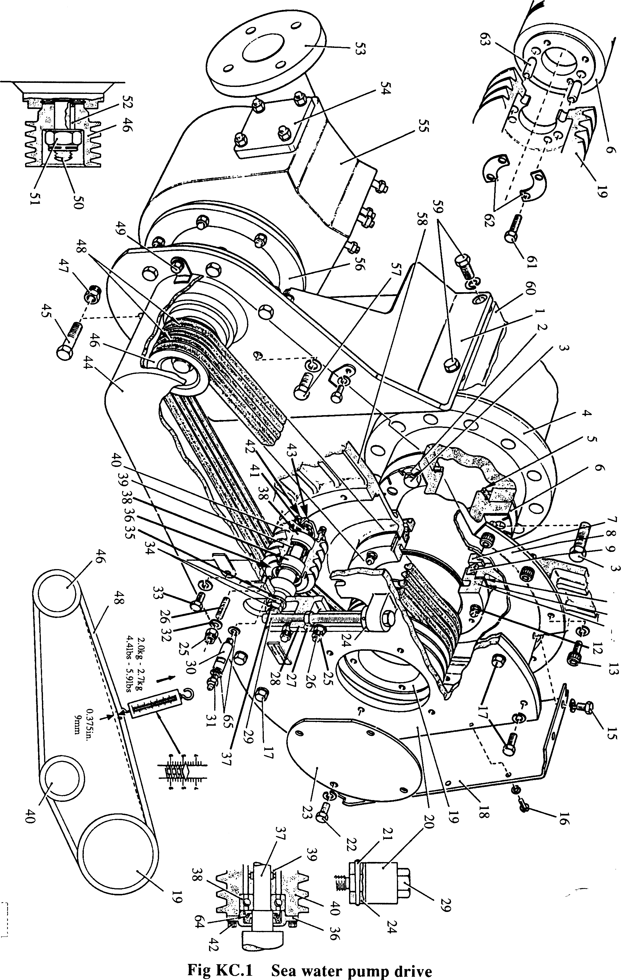

SPD00361

10 11 14

Key To Numbers

1. Valve Housing
2. Name plate
3. Tank
4. Gasket
5. Seal plate
6. Key
7. Plug
8. Rotation indicator plate
9. Plug
10. Rotary seal assembly
11. Flinger
12. Grease seal cap
13. Bevelled retainer
14. Shaft
15. Bearing, drive end
16. Bearing housing
17. Bearing, impeller end
18. Grease seal
19. Impeller
20. Diffuser
21. Tabwasher
22. Domed nut, impeller
23. 'O’ ring
24. Gasket, tank to valve housing
25. Washer
26. Drain plug
27. Chain, drain plug
28. Anchor plate, drain plug
29. Suction branch
30. Upper weight
31. Clack/check valve
32. Lower weight
33. Sealing washer
34. Gauge plug
35. Gasket
36. Valve seat
37. Gasket
38. Blanking plate
39. Spring washer
40. Nut
41. Stud
42. Spring
43. Carrier and drive
44. Carbon seal
45. Ceramic counterface
46. Rubber carrier

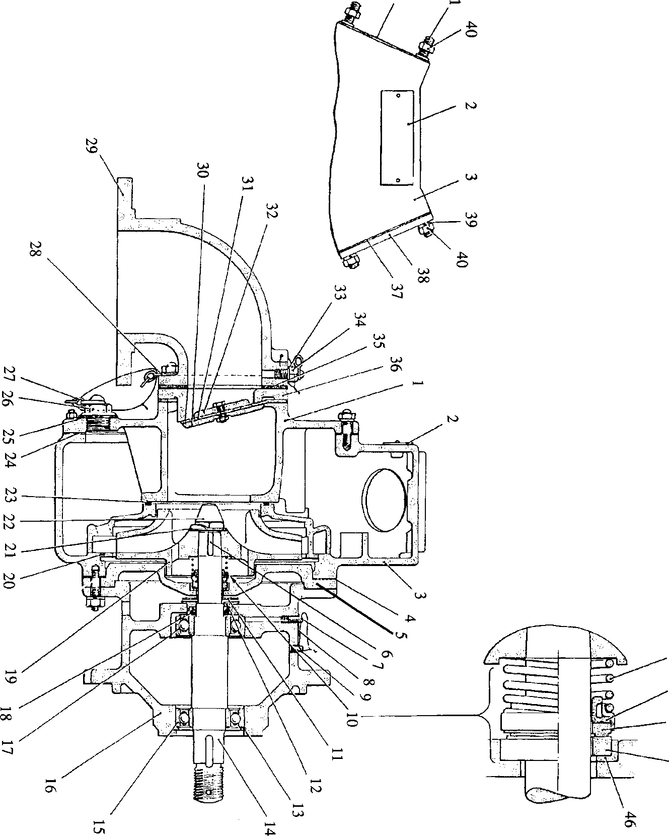

**SPD00355**

**Fig KC.2 Pegson sea water pump**